Unbalanced Time Series Data Handling

* Focal Loss

Doesn’t apply to Gradient Boosting Model

Applied to logistic regression and random forest

Applied to MLP Classifier

Result below is using the reweighting method--

Logistic Regression Performance:

AUC Score: 0.9434

Classification Report:

precision recall f1-score support

0 1.00 0.97 0.98 320866

1 0.37 0.84 0.52 7585

accuracy 0.96 328451

macro avg 0.69 0.90 0.75 328451

weighted avg 0.98 0.96 0.97 328451

Random Forest Performance:

AUC Score: 0.9347

Classification Report:

precision recall f1-score support

0 0.99 0.99 0.99 320866

1 0.72 0.65 0.68 7585

accuracy 0.99 328451

macro avg 0.86 0.82 0.84 328451

weighted avg 0.99 0.99 0.99 328451

Below model is done using sample weight

Gradient Boosting Performance:

AUC Score: 0.9558

Classification Report:

precision recall f1-score support

0 1.00 0.22 0.37 320866

1 0.03 1.00 0.06 7585

accuracy 0.24 328451

macro avg 0.51 0.61 0.21 328451

weighted avg 0.98 0.24 0.36 328451

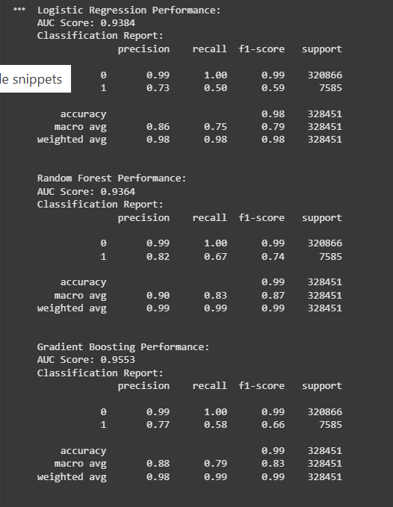

Mlp classifier

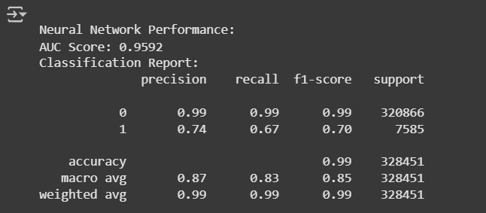

LSTM

